Celebrating Ndi-Igbo
ACCLAIMING PEOPLE OF IGBO DESCENT
Oby Onyioha
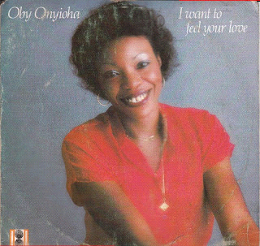
A baby-voiced vocalist with a toothy grin, Onyioha represented the new wave of Nigerian female pop singers emerging with the arrival of the 1980s.
Oby Onyioha's biggest hits included "I Want To Feel Your Love" and "Enjoy Your Life" - both a good mix of afro boogie / disco / electro soul. The former was so big in Europe that on an auction on Ebay it went for $700.
Brought up in Aba, Oby is the daughter of His Holiness Ogbaja (Prophet) Kama Onu Kama Onyioha, Head of the Godian Religion.
Other amazing tracks from Oby included 'Nigeria's gonna make it', 'Party party', and 'Break it' produced by Sunny Ade.
Music
Enjoy Your Life
Source: Comb & Razor, Various Funk Blogs.
Posted by SanChi Media at Tuesday, March 17, 2009 1 comment:
Email ThisBlogThis!Share to TwitterShare to FacebookShare to Pinterest
Labels: funk, igbo, Oby Onyioha

